UNIT-01
Computer and Operating System
Definition:
A computer is a programmable electronic device that accepts raw data as input, processes it by executing a sequence of logical and arithmetic operations under the control of software, converts it into meaningful information, and stores the results for future use with high speed, accuracy, and automation.

Computers operate based on binary code (a system of 0s and 1s) and can process a large amount of data quickly and accurately.

Key Characteristics of a computer:
Speed: | Computers operate at extremely high speeds, processing millions of instructions per seconds (MIPS). Modern CPUs can perform billions of calculations per second and it is measured in GHz
Accuracy: | Computers are highly accurate. Errors in output result are generally due to the incorrect input data or faulty programs.
Storage: | Computer can store vast amount of data in primary memory (RAM) and secondary memory (HDD, SDD). Data can be retrieved quickly when required.
Automation: | Once a program is loaded in the computer executes it automatically without human intervention at each step.

Classification:
Computers can be classified based on various criteria, such as purpose, size, functionality, and data handling capabilities. Below are the major classifications:
- Based on Purpose:
- General Purpose Computers:
- Multi-tasking Ability
→ Can perform many different tasks like typing, coding, browsing, gaming, etc.
- Programmable
→ Can run different programs/software as per user needs.
- Common Usage
→ Used in homes, offices, schools
→ Examples: Desktop, Laptop, Tablet
- Special Computer Purpose:
- Single-task Oriented
→ Designed to perform only one specific task
- High Efficiency
→ Works faster and more accurately for that particular task
- Limited Flexibility
→ Cannot perform multiple tasks like general-purpose computers
→ Examples: ATM, traffic control system, medical machines
- Based on Size and Performance:

- Supercomputers:
- Highest Speed & Power
→ Fastest computers with very high processing capability
- Handles Massive Data
→ Can process huge amounts of data in seconds
- Used for Complex Tasks
→ Used in weather forecasting, space research, scientific simulations

- Mainframe Computers:
- Large-Scale Processing
→ Designed to handle huge volumes of data
- Multi-User Support
→ Can support hundreds or thousands of users at the same time
- Used in Big Organizations
→ Used in banks, airlines, government systems
- Minicomputers:
- Medium Size & Power
→ Smaller than mainframes but more powerful than microcomputers
- Multi-User System
→ Can support multiple users at the same time
- Departmental Use
→ Used in small organizations or departments (now replaced by servers)
- Microcomputers:
- Small & Affordable
→ Compact size and low cost, suitable for individuals
- Single-User System
→ Designed for one user at a time
- Personal Use
→ Used in homes, schools, offices
→ Examples: Desktop, Laptop, Smartphone

- Based on Data Handling:
- Analog Computers:
- Continuous Data Processing
→ Works with continuous values (like temperature, speed)
- Less Accurate
→ Gives approximate results
- Specialized Use
→ Examples: Thermometer, speedometer
- Digital Computers:
- Discrete Data Processing
→ Works on binary (0 & 1)
- High Accuracy
→ Gives precise and reliable results
- Widely Used
→ Examples: Computer, laptop, smartphone
- Hybrid Computers:
- Combination System
→ Uses both analog + digital features
- High Speed & Accuracy
→ Combines speed of analog + accuracy of digital
- Medical & Scientific Use
→ Examples: ECG, CT scan

- Based on Functionality:

- Desktop Computers:
- Fixed Location Usage
→ Desktop computers are designed to be used at a single place and are not easily portable
- Higher Performance Capability
→ They generally offer better performance and storage compared to portable devices
- Common for Work and Study
→ Widely used in homes, offices, and schools for tasks like work, study, and gaming

- Portable Computers:
- Easy to Carry and Move
→ Portable computers are lightweight and can be easily carried anywhere
- Battery-Based Operation
→ They can operate on battery power without needing constant electricity supply
- Flexible Usage Anywhere
→ Used in different locations like home, college, or while traveling
→ Examples include laptops, tablets, and smartphones
- Embedded Systems:
- Built into Devices
→ Embedded systems are integrated within larger devices or machines
- Designed for Specific Tasks
→ They are created to perform a single dedicated function efficiently
- Automatic Working System
→ These systems work automatically with minimal or no user intervention
→ Examples include washing machines, cars, and industrial robots
- Based on Generation:
Generation | Time Period | Technology Used | Key Features | Example
First Generation | 1940 – 1956 | Vacuum Tubes | Very large size, high power consumption, low reliability | ENIAC
Second Generation | 1956 – 1963 | Transistors | Smaller, faster, more reliable, less heat generation | IBM 1401
Third Generation | 1964 – 1971 | Integrated Circuits (IC) | More compact, efficient, improved speed and accuracy | IBM System/360
Fourth Generation | 1971 – Present | Microprocessors | Very small size, high speed, affordable, personal computers developed | Modern PCs
Fifth Generation | Present & beyond | Artificial Intelligence & Quantum Computing | Advanced processing, machine learning, natural language understanding | AI systems
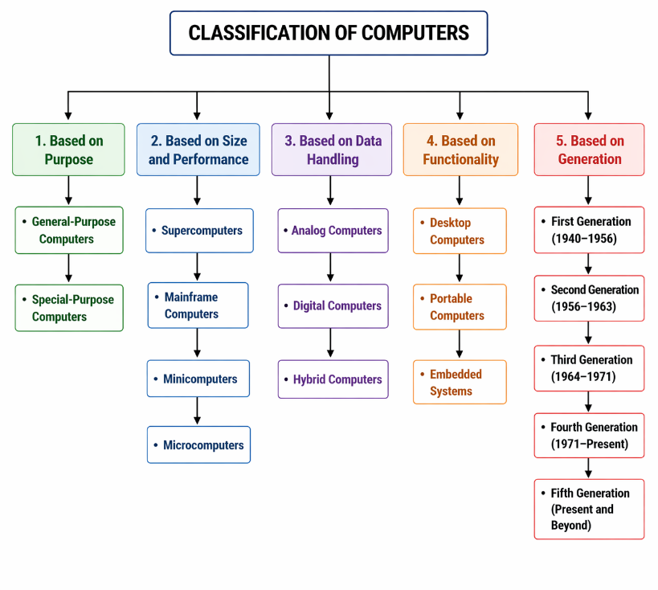

Organisation:
CPU organization refers to the internal structure and arrangement of components like registers, buses, and control units inside the CPU.

It defines how these components work together to process instructions and perform operations efficiently.

CPU:
The Central Processing Unit (CPU), often referred to as the "brain" of the computer, is a critical hardware component responsible for executing instructions from programs and performing calculations. It processes data and coordinates tasks between all other hardware components.
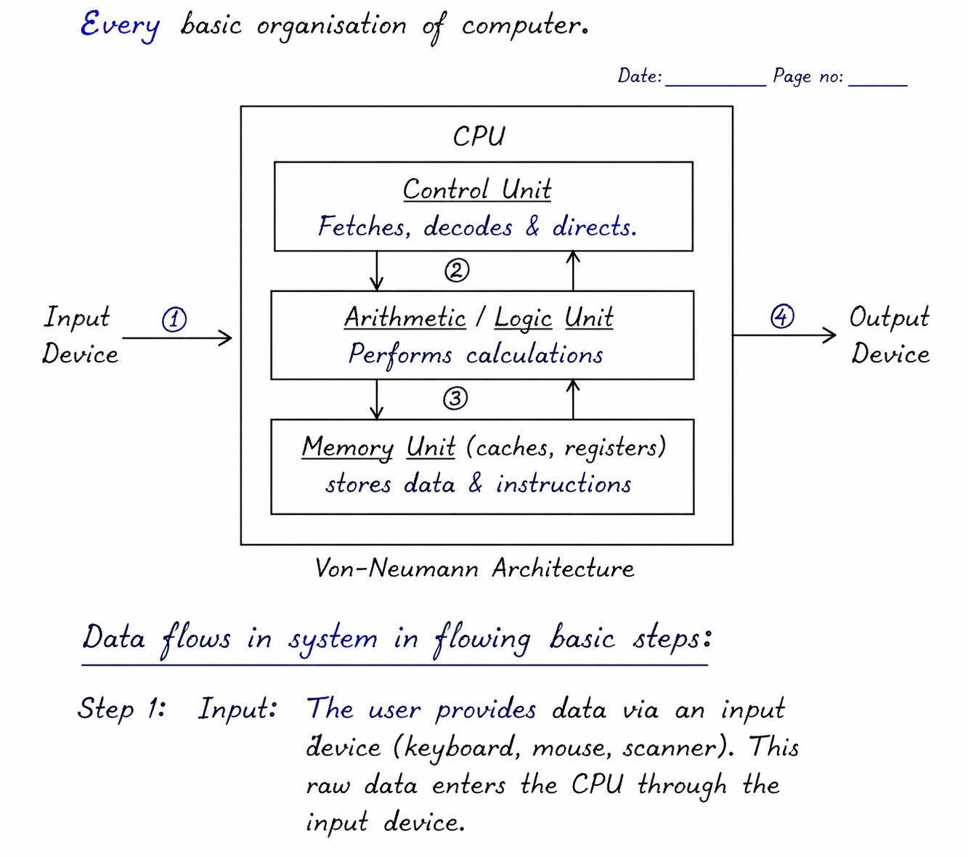
Working of CPU (Step-wise)
🔹 Step 1: Input
- The user provides raw data and instructions using input devices such as a keyboard, mouse, or scanner.
- This input data is then transferred to the CPU for further processing.
🔹 Step 2: Fetch
- The Control Unit (CU) fetches the required instructions and data from the Memory Unit.
- These instructions are brought into the CPU so that they can be processed step by step.
🔹 Step 3: Decode
- The Control Unit decodes the fetched instruction to understand what operation is to be performed.
- It interprets the instruction and prepares the necessary signals for execution.
🔹 Step 4: Execute
- The Arithmetic Logic Unit (ALU) performs the required arithmetic or logical operations on the data.
- During this stage, data may also be read from memory or written back to memory as needed.
🔹 Step 5: Store
- After execution, the result obtained is stored back in the Memory Unit.
- This allows the result to be used later whenever required.
🔹 Step 6: Output
- Finally, the processed result is sent to the output device such as a monitor or printer.
- The user can then view or use the final output information.
Components of a CPU
- Control Unit (CU):
  - Directs the operation of the computer.
  - Fetches instructions from memory, decodes them, and directs the execution.
  - Coordinates data flow between the CPU, memory, and peripherals.
- Arithmetic Logic Unit (ALU):
  - Performs arithmetic operations (e.g., addition, subtraction) and logical operations (e.g., AND, OR).
  - Handles calculations required by programs.
- Registers:
- Registers are very small, high-speed storage locations present inside the CPU that are used to temporarily store data, instructions, and memory addresses during the execution of a program.
- They are much faster than main memory (RAM) and are directly accessed by the CPU, which helps in increasing the overall speed of processing.
- Different types of registers perform specific functions, such as the Program Counter (PC) which holds the address of the next instruction, the Instruction Register (IR) which stores the current instruction being executed, and the Accumulator (AC) which stores intermediate results of calculations.
- Since registers store data temporarily and are limited in size, they play a crucial role in the efficient and fast operation of the CPU.
- Cache Memory:
  - High-speed memory located within or very close to the CPU.
  - Stores frequently accessed data and instructions to improve processing speed.
- Clock:
  - The CPU clock synchronizes operations and determines the processing speed.
  - Measured in GHz (gigahertz), indicating the number of cycles per second.

Bus Architecture:
Bus architecture is a communication system within a computer that transfers data between components such as the CPU, memory, and peripherals. It acts as a highway for data flow, ensuring components can interact and work together efficiently.
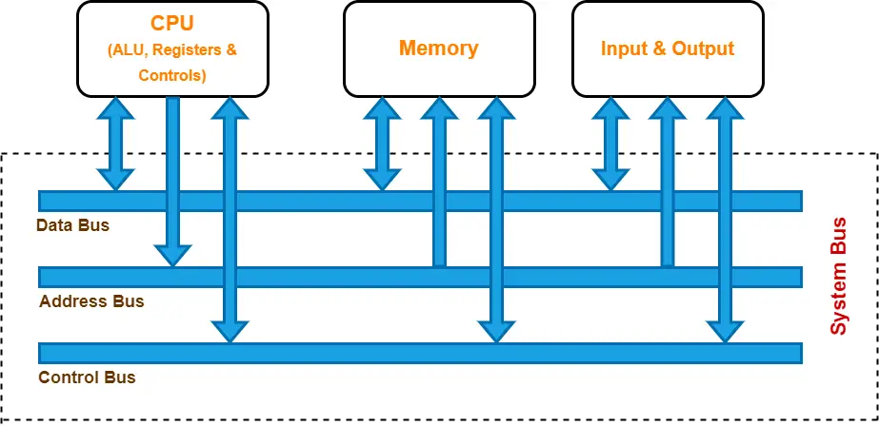

Key Components of Bus Architecture
- Data Bus:
  - Transfers actual data between the CPU, memory, and I/O devices.
  - Width (measured in bits, e.g., 32-bit or 64-bit) determines how much data can be transmitted simultaneously.
- Address Bus:
  - Carries memory addresses from the CPU to other components to specify where data should be read from or written to.
  - Width determines the addressable memory range. For example:
    - 32-bit address bus can address 2³² (4 GB) of memory.
    - 64-bit address bus can address much larger memory.
- Control Bus:
  - Sends control signals to manage and coordinate operations.
  - Examples of control signals:
    - Read/Write (R/W) signals.
    - Interrupt signals.
    - Clock signals for synchronization.
Types of Bus Architectures
- System Bus:
  - Connects the CPU, memory, and other major components.
  - Includes the data bus, address bus, and control bus.
- I/O Bus:
  - Connects peripheral devices like printers, keyboards, and storage to the system.
- Internal and External Buses:
  - Internal Bus: Operates within the CPU to connect components like the ALU, registers, and cache.
  - External Bus: Interfaces the CPU with external devices (e.g., PCI, USB, and SATA).
Bus Topologies
- Single Bus:
  - All components share a single communication line.
  - Simple design but may face bottlenecks under heavy data traffic.
- Multiple Bus:
  - Uses separate buses for different tasks (e.g., a dedicated I/O bus and a memory bus).
  - Reduces traffic and improves performance.
Types of Modern Buses
Bus Standard | Type | Speed | Common Use
PCIe (PCI Express) | Serial | Up to 128 GB/s (PCIe 5.0 x16) | Graphics cards, NVMe SSDs, network cards
USB 3.2 / USB 4 | Serial | Up to 40 Gbps | Keyboards, mice, external storage, phones
SATA III | Serial | 6 Gbps | Hard drives and SATA SSDs
DDR5 Memory Bus | Parallel | Up to 51.2 GB/s | Main memory (RAM) connection
Thunderbolt 4 | Serial | 40 Gbps | High-speed external devices, displays
Advantages of Bus Architecture
- Cost-effective and simple to implement.
- Easy to add or remove devices.
- Standardized interfaces allow compatibility with various components.
Challenges
- Bottlenecks: Shared buses can slow performance when multiple devices request access simultaneously.
- Latency: Communication delays may occur, especially in complex systems.
Modern computer systems use advanced bus architectures, like PCIe and USB, to handle the growing demand for speed, efficiency, and compatibility.
Instruction Set:
An instruction set is a collection of machine-level commands or instructions that a processor (CPU) can understand and execute. It defines how software communicates with the hardware, serving as the interface between the two.
Key Components of an Instruction Set

- Operation Codes (Opcodes):
  - Specifies the operation to be performed (e.g., ADD, SUB, LOAD, STORE).
- Operands:
  - The data on which the operation is performed. Operands can be:
    - Immediate: Values provided directly in the instruction.
    - Register: Data stored in CPU registers.
    - Memory: Data located in RAM or other storage.
Types of Instructions

- Data Transfer Instructions:
  - Move data between memory, registers, or I/O.
  - Examples: LOAD, STORE, MOV.
- Arithmetic Instructions:
  - Perform mathematical operations.
  - Examples: ADD, SUB, MUL, DIV.
- Logical Instructions:
  - Perform logical operations like AND, OR, and NOT.
  - Examples: AND, OR, XOR.
- Control Flow Instructions:
  - Change the sequence of instruction execution.
  - Examples: JUMP, CALL, RETURN, BRANCH.
- Input/Output Instructions:
  - Handle communication with peripheral devices.
  - Examples: IN, OUT.

Types of Instruction Sets

- CISC (Complex Instruction Set Computing):
  - Features a large number of complex instructions.
  - Fewer instructions are needed for high-level tasks.
  - Example Processors: Intel x86.
- RISC (Reduced Instruction Set Computing):
  - Focuses on a smaller set of simple instructions that execute quickly.
  - Relies on software to combine simple instructions for complex tasks.
  - Example Processors: ARM, MIPS.
- VLIW (Very Long Instruction Word):
  - Encodes multiple operations in a single instruction.
  - Optimized for parallel processing.
- SIMD (Single Instruction, Multiple Data):
  - Executes one instruction on multiple data points simultaneously.
  - Common in graphics and multimedia processing.

The choice of an instruction set impacts a processor's performance, power consumption, and compatibility with software. Modern processors often blend features of CISC and RISC to achieve a balance between complexity and efficiency.
🧠 Memory and Storage
✍️ Introduction
Memory and storage are essential components of a computer system used to store data and instructions. They enable the computer to perform operations efficiently and retain information for present and future use. Memory is mainly used for temporary and fast access by the CPU, whereas storage is used for permanent data retention.
⚖️ Basic Difference between Memory and Storage

Basis | Memory (Primary Memory) | Storage (Secondary Storage)
Nature | Temporary (volatile) | Permanent (non-volatile)
Speed | Very fast | Slower than memory
Usage | Used by CPU directly | Used for long-term storage
Capacity | Smaller | Larger
Examples | RAM, Cache, Registers | HDD, SSD, Pen Drive, CD/DVD

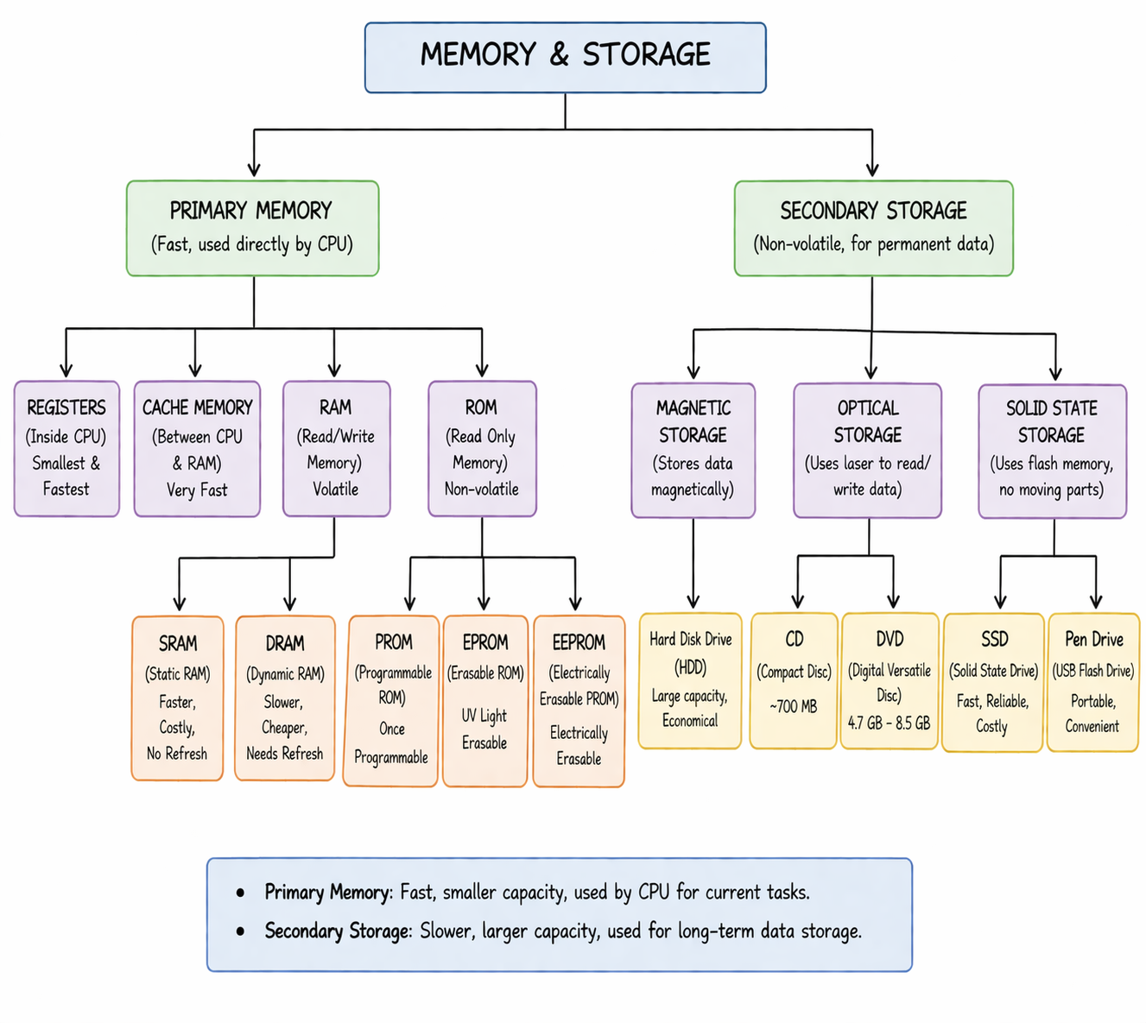

🧩 Types of Memory and Storage
1. Primary Memory
Primary memory is the main memory of the computer that is directly accessed by the CPU. It is fast but has limited capacity.
Components:
- Registers
Registers are the smallest and fastest memory units located inside the CPU. They temporarily hold data and instructions currently being processed.

- Cache Memory
Cache memory is a high-speed memory located between CPU and RAM. It stores frequently used data to improve processing speed.

- RAM (Random Access Memory)
RAM is a volatile memory used to store data temporarily while the computer is running.
  - SRAM (Static RAM): Faster, more expensive, does not require refreshing.
  - DRAM (Dynamic RAM): Slower, cheaper, requires periodic refreshing.

- ROM (Read Only Memory)
ROM is a non-volatile memory used to store permanent instructions.
  - PROM: Programmable once.
  - EPROM: Can be erased using ultraviolet light.
  - EEPROM: Can be erased electrically.

2. Secondary Storage
Secondary storage is used to store data permanently. It is not directly accessed by the CPU and has a larger capacity.
Types:
- Magnetic Storage
Magnetic storage stores data by using magnetic fields on a storage medium. It is commonly used for storing large amounts of data at low cost.
Example: Hard Disk Drive (HDD)

- Optical Storage
Optical storage uses laser technology to read and write data on discs. It is mainly used for media storage and data sharing.
Examples: CD, DVD

- Solid State Storage
Solid state storage uses flash memory to store data electronically without moving parts, making it fast and reliable.
Examples: SSD, Pen Drive

📝 Conclusion
In conclusion, memory and storage are both vital for the functioning of a computer system. Primary memory ensures fast processing, while secondary storage provides long-term data preservation. Both work together to make computing efficient and reliable.

🖥️ Input and Output (I/O) Devices
✍️ Introduction
Input and Output devices are essential components of a computer system that enable communication between the user and the computer. Input devices are used to enter data and instructions into the computer, while output devices present the processed information to the user in a meaningful form.

⚖️ Basic Difference between Input and Output Devices

Basis | Input Devices | Output Devices
Function | Send data to computer | Receive data from computer
Direction | User → Computer | Computer → User
Purpose | Provide instructions and data | Display results
Examples | Keyboard, Mouse, Scanner | Monitor, Printer, Speaker

🧩 Types of I/O Devices
1. Input Devices
Input devices are used to enter data and instructions into the computer system.
Examples:
- Keyboard
Used to input text, numbers, and commands.
- Mouse
A pointing device used to control the cursor and select items.
- Scanner
Converts physical documents into digital form.
- Microphone
Inputs sound into the computer.
- Webcam
Captures images and videos as input.

2. Output Devices
Output devices display or produce the processed information from the computer.
Examples:
- Monitor
Displays visual output such as text, images, and videos.
- Printer
Produces hard copies of documents.
- Speaker
Outputs sound and audio.
- Headphones
Provide personal audio output.
- Projector
Displays output on a large screen.

3. Input-Output Devices (Both Functions)
Some devices can perform both input and output functions.
- Touchscreen – Acts as both input and output device.
- Modem – Sends and receives data.
- Network Card – Handles communication between devices.

📝 Conclusion
In conclusion, I/O devices play a vital role in the functioning of a computer system by enabling interaction between the user and the machine. Input devices provide data, and output devices present results, making the system useful and user-friendly.

🖥️ System and Application Software:
Software is a collection of programs, procedures, and related data that instructs a computer to perform tasks. It is mainly classified into two broad categories: System Software and Application Software. Both are essential for the proper functioning of a computer system.

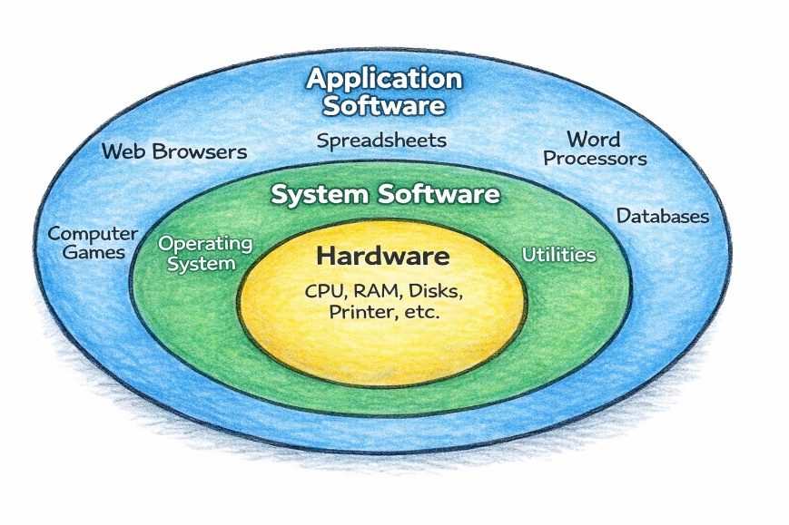

1. System Software
System software is the set of programs that controls and manages the operations of computer hardware. It acts as an interface between the user, hardware, and application software. It provides a platform on which application programs can run.
Functions of System Software:
- Controls and coordinates hardware devices.
- Manages memory, processor, and storage.
- Provides security and file management.
- Helps in running application software.
- Translates programming languages into machine language.
Types of System Software:
(a) Operating System
An operating system is system software that manages the hardware and software resources of a computer. It acts as an interface between the user and the computer system. It controls memory, files, input and output devices, and running processes. It helps application programs run smoothly and efficiently. It is essential for the proper functioning of a computer system.
Examples: Microsoft Windows, Linux, macOS
(b) Language Translators
These convert high-level language programs into machine language.
- Compiler
- Interpreter
- Assembler
(c) Utility Programs
These programs maintain and protect the computer.
Examples: Antivirus software, disk clean-up, backup tools.
(d) Device Drivers
These help the operating system communicate with hardware devices such as printers, keyboards, and scanners.

2. Application Software
Application software is a set of programs designed to help users perform specific tasks. These programs are created according to user requirements.
Functions of Application Software:
- Helps in writing documents.
- Performs calculations.
- Creates presentations.
- Manages data.
- Supports communication and entertainment.
Types of Application Software:
(a) General Purpose Application Software
Used for common day-to-day tasks.
Examples:
Microsoft Word – word processing
Microsoft Excel – calculations
Microsoft PowerPoint – presentations
Google Chrome – internet browsing
(b) Special Purpose / Customized Software
Developed for specific organizations or users.
Examples:
- Payroll system
- Railway reservation system
- Hospital management system
- Banking software

Difference Between System Software and Application Software
Basis | System Software | Application Software
Meaning | Software that manages hardware and system operations | Software used to perform specific user tasks
Purpose | To run and control the computer system | To solve user problems
Dependency | Required for system functioning | Runs on system software
Execution | Starts when computer boots | Runs when user starts it
User Interaction | Less direct interaction | Direct interaction
Examples | Windows, Linux, Drivers | Word, Excel, Chrome

Relationship Between Both
System software provides the environment in which application software works. Without system software, application software cannot run. For example, Microsoft Word requires Microsoft Windows or another operating system to function.

Conclusion
System software is necessary for managing the computer and hardware resources, while application software is used for completing user-oriented tasks. Both types of software are important and work together to make the computer useful and efficient.

- Define computer¹ and explain its classification². Dec 2025
- Describe CPU organization³ including registers⁴, bus architecture⁵ and instruction set.⁶ Dec 2025
- Explain memory and storage systems⁷ along with I/O devices. Dec 2025
- Discuss system software and application software with examples. Dec 2025
- Explain operating systems and its main functions. Dec 2025
- Discuss file, process and memory management in operating systems. Dec 2025
- Classify computers based on size and functionality. Compare supercomputers, mainframes and embedded systems. June 2025.
- Explain the architecture and working of a CPU with a labelled diagram. June 2025.
- Define an Operating System. Discuss its structure and explain the concept of a kernel. June 2025.
- What is application software and how does it differ from system software? Dec 2024.
- Define computer memory and differentiate between primary and secondary memory. Dec 2024.
- Discuss the classification of computer with example. Dec 2024.
- What are the advantages of a computer? Discuss with suitable examples. Dec 2024.
- Explain the organization of computer with help of block diagram. June 2024.
- Give examples of basic mathematical functions in Excel such as SUM, AVERAGE and MAХ. June 2024.
- How do you insert headers and footers into a Word document? What content can be included in headers and footers? Discuss. June 2024.
- What is Microsoft Office and what is its primary purpose? June 2024.
- Remote Sensing and GIS June 2024.
- I/O Device June 2024.
- What functions do application and system software perform in a computer system? What distinguishes them from one another? Dec 2023.
- Could you explain the various memory and storage techniques typically utilized by computers. Dec 2023.
- What are the primary features and applications of Microsoft PowerPoint for generating presentations? Dec 2023.
- What is an operating system, and what are its key responsibilities in a computer system? Also, discuss various types of operating systems now in use. Dec 2023.
- Describe the following: June 2023
I) Remote sensing and GIS
ii) Computer applications in E-business
- Explain I/O devices in detail with suitable examples. June 2023.
- Discuss the classification computer with examples. Nov 2022.
- Define Operating System. Briefly explain the function. Nov 2022.
- BUS Architecture. Nov 2022.
- MS Word Vs MS Excel. Nov 2022.
- What is E-Commerce? Write the advantages and disadvantages. Nov 2022.
- Explain the applications of computer in the field of Meteorology and Climatology, Multimedia and Animation. June 2022.
- Briefly explain the functions of operating system. June 2022.
- Explain different computer memories in RAM, ROM, CACHE, REGISTER and HARD DISK in detail. June 2022.

